**Assignments 5.6**

**Driver class:**

import org.apache.hadoop.fs.Path;

import org.apache.hadoop.conf.*;

import org.apache.hadoop.mapreduce.Job;

import org.apache.hadoop.mapreduce.lib.input.FileInputFormat;

import org.apache.hadoop.mapreduce.lib.input.TextInputFormat;

import org.apache.hadoop.mapreduce.lib.output.FileOutputFormat;

import org.apache.hadoop.mapreduce.lib.output.SequenceFileOutputFormat;

import org.apache.hadoop.mapreduce.lib.output.TextOutputFormat;

import org.apache.hadoop.io.IntWritable;

import org.apache.hadoop.io.Text;

import org.apache.hadoop.mapreduce.lib.input.SequenceFileInputFormat;

public class DriverClass {

@SuppressWarnings("deprecation")

public static void main(String[] args) throws Exception {

Configuration conf = new Configuration();

Job job = new Job(conf, "Demo");

job.setJarByClass(DriverClass.class);

job.setMapOutputKeyClass(Text.class);

job.setMapOutputValueClass(IntWritable.class);

job.setOutputKeyClass(Text.class);

job.setOutputValueClass(IntWritable.class);

job.setMapperClass(MapperClass.class);

job.setReducerClass(ReducerClass.class);

job.setInputFormatClass(SequenceFileInputFormat.class);

job.setOutputFormatClass(TextOutputFormat.class);

FileInputFormat.addInputPath(job, new Path(args[0]));

FileOutputFormat.setOutputPath(job,new Path(args[1]));

/*

Path out=new Path(args[1]);

out.getFileSystem(conf).delete(out);

*/

job.waitForCompletion(true);

}

}

**Mapper Class:**

import java.io.IOException;

import org.apache.hadoop.io.IntWritable;

import org.apache.hadoop.io.LongWritable;

import org.apache.hadoop.io.Text;

import org.apache.hadoop.mapreduce.*;

public class MapperClass extends Mapper<Text,IntWritable, Text, IntWritable> {

Text outKey=new Text();

IntWritable one=new IntWritable();

public void map(LongWritable key, Text value, Context context)

throws IOException, InterruptedException {

String data[]=value.toString().split(",");

outKey.set(data[0]);

context.write(outKey,one);

}

}

**Reducer Class:**

import java.io.IOException;

import org.apache.hadoop.io.IntWritable;

import org.apache.hadoop.io.LongWritable;

import org.apache.hadoop.io.Text;

import org.apache.hadoop.mapreduce.*;

public class ReducerClass extends Reducer<Text, IntWritable, Text, IntWritable>

{

IntWritable outValue = new IntWritable();

public void reduce(Text key, Iterable<IntWritable> values,Context context) throws IOException, InterruptedException

{

int s = 0;

for (IntWritable value : values) {

s += value.get();

}

outValue.set(s);

context.write(key, outValue);

}

}

**Jar File:**

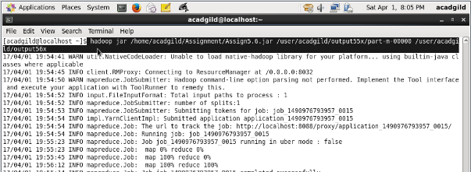

**Output:**

